**SMART PARKING**

**BLOCK DIAGRAM**

LDR

MICROCONTROLLER

LDR

LDR

LCD

**FLOW CHART**

NA

Z=?

NA

X=?

AV

NA

X=0 X=1

Y=?

Y=0 Y=1

AV

Z=0 Z=1

AV

CIRCUIT DIAGRAM

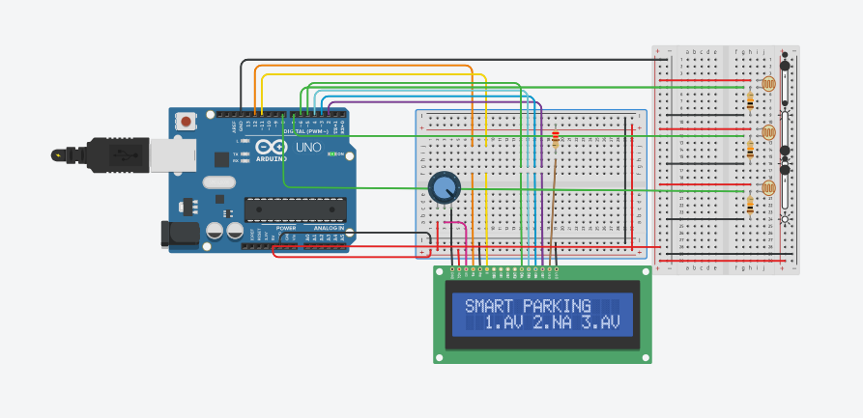

PROGRAM:

#include <LiquidCrystal.h>

// initialize the library with the numbers of the interface pins

LiquidCrystal lcd(12, 11, 5, 4, 3, 2);

void setup() {

// set up the LCD's number of columns and rows:

Serial.begin(9600);

lcd.begin(16, 2);

lcd.print("SMART PARKING");

pinMode(6,INPUT);

pinMode(7,INPUT);

pinMode(8,INPUT);

}

void loop() {

// set the cursor to column 0, line 1

// (note: line 1 is the second row, since counting begins with 0):

lcd.setCursor(0,1);

if(digitalRead(6)==0)

{

lcd.setCursor(2, 1);

lcd.print("1.AV");

}

else if(digitalRead(6)==1)

{

lcd.setCursor(2,1);

lcd.print("1.NA");

}

if (digitalRead(7)==0)

{

lcd.setCursor(7,1);

lcd.print("2.AV");

}

else if(digitalRead(7)==1)

{

lcd.setCursor(7,1);

lcd.print("2.NA");

}

if(digitalRead(8)==0)

{

lcd.setCursor(12,1);

lcd.print("3.AV");

}

else if(digitalRead(8)==1)

{

lcd.setCursor(12,1);

lcd.print("3.NA");

}

}